Content Audit Report Template
Prepared by:
Prepared for:
Date:

Contents
Executive Summary 3
Highlights 3
Recommendations 3
Tools and Analysis 3
Page Analysis 4
Pages Ranked by Visits 4
Page View Trends 4
Path Analysis 5
Keyword Analysis 6
Site Search Terms 6
Social Media 7
Community 7
SEO 7
Content Audit Resources 7

Executive Summary

This is your opportunity to provide a high-level view of the main findings of the content audit. Use the space here to explain report highlights, recommendations, and tools and analysis used.

Highlights
- Page analysis …
- Keyword analysis …
- Social Media analysis …

Recommendations
- Keep them short.
- Make them realistic.
- Provide a handful; don’t overwhelm the client/program manager.

Tools and Analysis
- Tools used for this content audit: WebTrends, Google Analytics, Google Webmaster Tools, online surveys, etc
- Time spans studied for profiles varied, depending on tool and analysis. Each is noted with analysis.
- Total site (or section) pages: xx; total pages in xx section: xx (xx% of site pages)

Page Analysis
In each section provide some introductory text for that analysis. Here in the Page Analysis section explain the tools you used and the timeframes studied. Page analysis might be divided by common key metrics, such as Pages Ranked by Visits, Pages Ranked by Average Time Spent on Page, Page View Trends, and Path Analysis. Consider compare date ranges, too, as part of your analysis (for example, first 6 months of one year compared to first 6 months of previous year).

Pages Ranked by Visits
Pretty standard stuff. Use snapshots from your metrics tools, or build your own tables to indicate page popularity.

Page View Trends
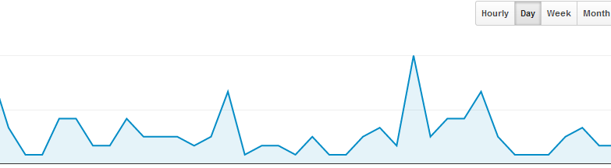
explain spikes in traffic

Use the Snipping Tool in MS Windows for screen grabs:
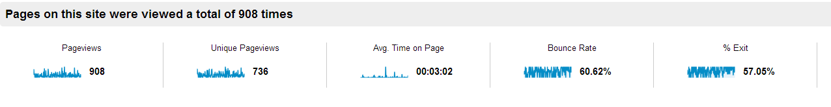Highlights:
- Select data points to explain in highlight sections below screenshots.
- Focus on strengths, weaknesses, and opportunities in the data.
- Create a picture for action.

Path Analysis
Path analysis can be a powerful analysis tool to show the customer journey through a site. You’ll have to keep this analysis targeted and simple. Snapshot or import graphs from metrics tools.

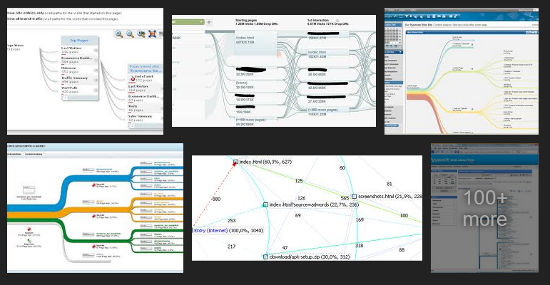

Keyword Analysis
Keyword analysis can combine site seach analysis, meta content (from Google Webmaster Tools), and Google site search analysis. Wordles are effective ways to demonstration visitor site search trends. See http://www.wordle.net/advanced to create your own.
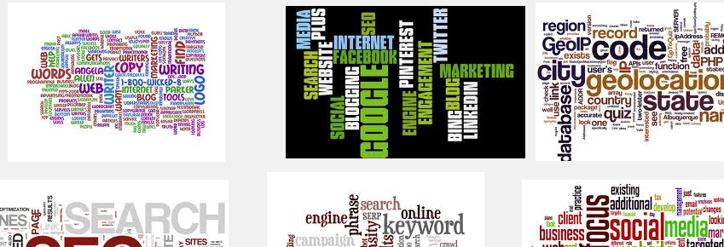

Site Search Terms
Analysing site search terms (both onsite and from search engines) is a powerful way to show trends and catch trends; improve page keywords; and support SEO and on-page content strategies. Pull data and chart judiciously; it can be overwhelming. But there is gold here.

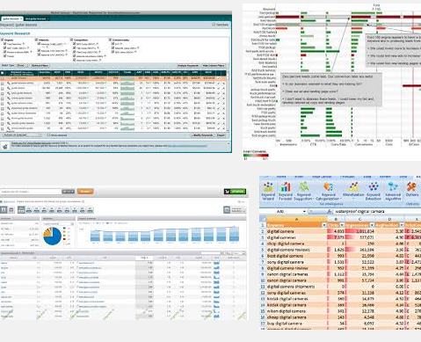

Social Media

Community

SEO

Consider as many topics as needed in your content audit. Other categories to consider include branding, design, PPC, accessibility, content, links, information architecture, and video.

Content Audit Resources
- Annie Cushing’s Craziest Audit Checklist on the Internet and Must Have Audit Tools
- Content Analysis Heuristics, by Fred Leise
- Wikipedia article on Content Audit

